**OBJECT IDENTIFICATION (WEB UI)**

Navigate to https://material.angular.io/components/table/overview

1. **Table Basic Example** laying under Getting Started

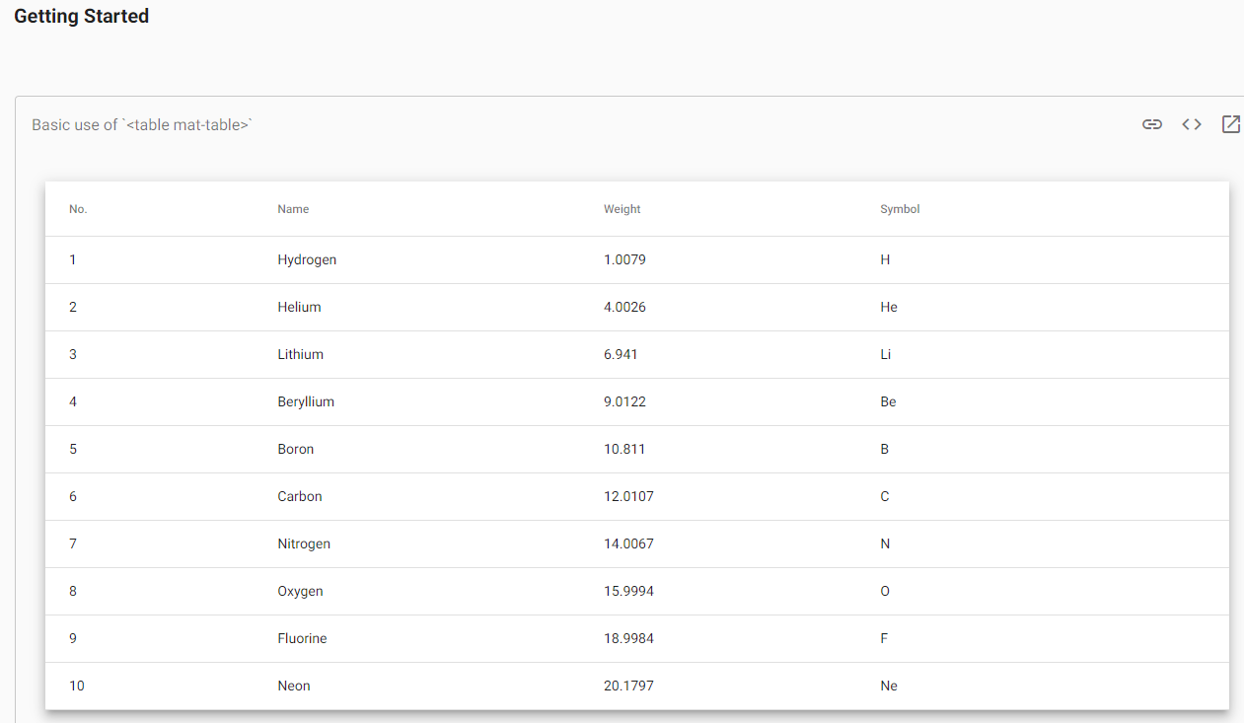

**XPATH://*[@id="table-basic"]**

**CSS:** **#table-basic**

2. Identify **Weight** based on Name in the above table. Ex: Boron is 10.811

**XPATH:** //*[@id="table-basic"]//table-basic-example/table//td[contains(text(),'Boron')]//following-sibling::td[contains(@class,'mat-column-weight')]

**CSS:** **#table-basic table-basic-example table >tbody > tr:nth-child(5) > td:nth-child(2)**

**Cách bắt css nà k tối ưu vì nếu thay đỏi code elemet này sẽ k còn unique nữa**

**Nhưng tôi gặp vấn đề với syntax td:contains(text,’Boron’) nên khi bắt ntn nên tôi sẽ diễn giải cách làm tôi sẽ tìm thẻ( td có chứa text là ‘Boron’ + td có class** 'mat-column-weight…….’ ) trong thẻ tr của table basic

Ex: #table-basic table-basic-example table tbody tr:has(td:contains("Boron")) + td.mat-mdc-cell.mdc-data-table__cell.cdk-cell.cdk-column-weight.mat-column-weight.ng-star-inserted

3. Identify **API Tab**



**XPATH:** **//a[@id='mat-tab-link-2']**

**CSS:** **#mat-tab-link-2**

4. In **API tab**. Identify all elements under **Interfaces** on the right side except the first item (4 items)

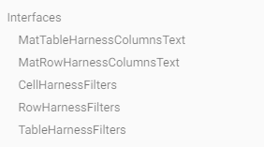

**XPATH:**

**MatRowHarnessColumnsText: //h3[@id='material-table-testing-interfaces']//following::h4[@id='MatRowHarnessColumnsText']**

**CellHarnessFilters: //h3[@id='material-table-testing-interfaces']//following::h4[@id='CellHarnessFilters']**

**RowHarnessFilters://h3[@id='material-table-testing-interfaces']//following::h4[@id='RowHarnessFilters']**

TableHarnessFilters://h3[@id='material-table-testing-interfaces']//following::h4[@id='TableHarnessFilters']

**CSS:**

MatRowHarnessColumnsTexth3#material-table-testing-interfaces ~ h4#MatRowHarnessColumnsText > code

CellHarnessFilters:h3#material-table-testing-interfaces ~ h4#CellHarnessFilters> code

RowHarnessFilters:h3#material-table-testing-interfaces ~ h4#RowHarnessFilters> code

TableHarnessFilters:h3#material-table-testing-interfaces ~ h4#TableHarnessFilters> code

***Note:***

*It might be noticed that we will bear some side effects when interacting with the CSS selector. You can describe the idea if it occurs.*

**Due date:** 09.Sep.2023